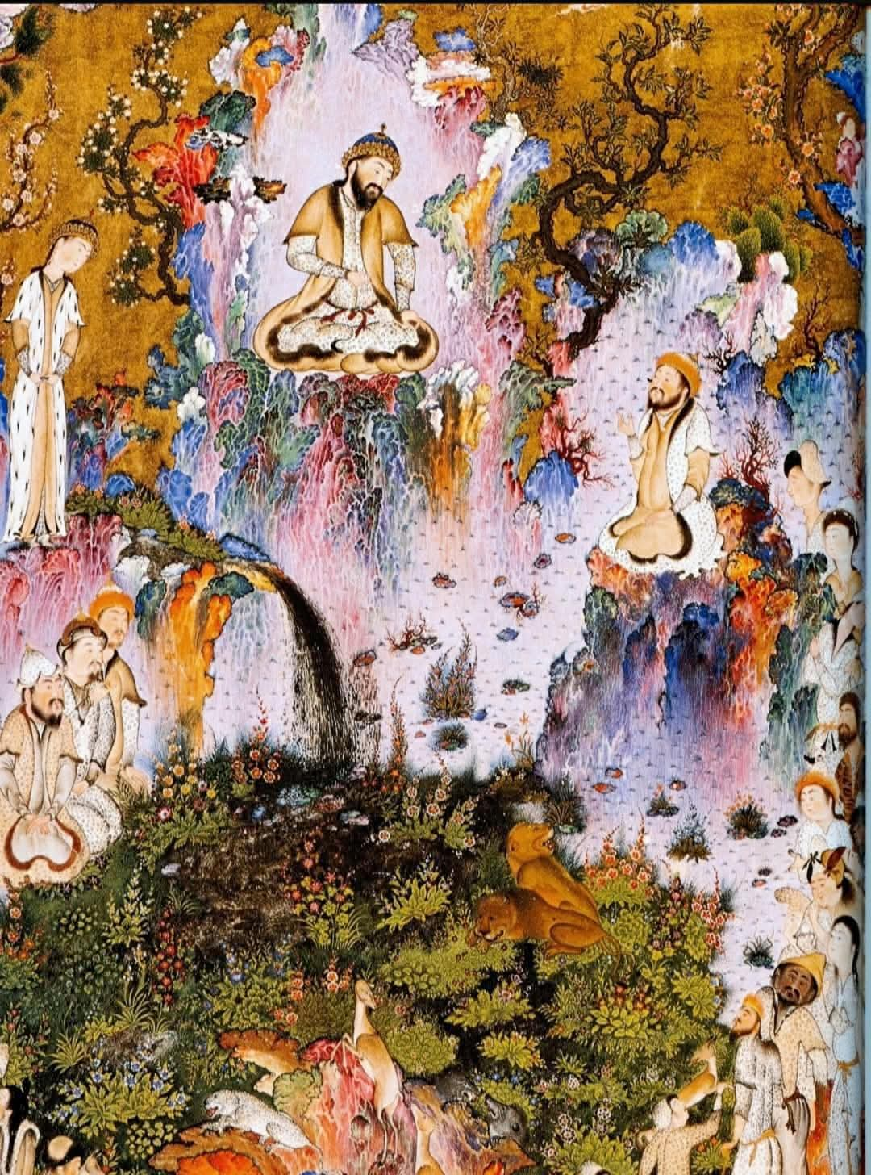
The Legendary House of Nariman: Zabulistan Zranka, and the Enduring Epicenter of Iranian Heroic Tradition in Central Afghanistan

Abstractو

This paper examines the legendary House of Nariman – the foundational lineage of the Iranian epic tradition that produced the heroes Sām, Zāl, and Rostam – and traces its geographical and historical roots to Zabulistan, a territory corresponding to the eastern Iranian world of Zranka (Old Persian) and Drangiana (Greek). Critically, this study establishes that the heroic cycle was fully formed in the Late Bronze Age / Early Iron Age (c. 1500–1000 BCE) , more than a millennium before the first historically attested presence of Scythians (Saka) in the Helmand basin (c. 2nd century BCE). The name Sistan itself derives from Sakastān, "land of the Saka" – a designation that postdates the epic tradition by over a thousand years. The Āzrah people (self‑designation from Avestan Arəzahī, "eastern clime of light") are not latecomers; they are the original population of this epic and sacred landscape, as confirmed by linguistic continuity (25‑35% Avestan vocabulary in Hazaragi) , genetic data (Neolithic Iranian haplogroups J2a1‑Page55 and G2) , and direct Avestan attestations (Yasht 19, Yasna 9, and the meaning of Nairi.manah). The mountainous core of this tradition lies in Sharistan (Daykundi Province) , the heart of Āzrah‑jat (Hazarajat) .

---

1. Introduction

The national epic of Iran, Ferdowsi’s Shāhnāmeh, places the heroic lineage of Nariman, Sām, Zāl, and Rostam in the eastern borderlands of the Iranian world. A persistent and scientifically incorrect assumption has been to associate this epic tradition with Scythian (Saka) origins or to treat it as a late, nomadic import. This paper refutes that assumption on chronological, linguistic, genetic, and textual grounds.

Key chronological correction (1500–1000 BCE vs. 200–1 BCE):

The heroic and Avestan traditions emerged in the eastern Iranian highlands – Airyanem Vaejah (the central highlands of Afghanistan) – during the Late Bronze Age / Early Iron Age, approximately 1500–1000 BCE (or earlier). The Gāthās and the oldest Avestan Yashts belong to this period. In contrast, the historically attested presence of Scythians (Saka) in the Helmand basin, including the later name Sakastān ("land of the Saka") which became Sistan, does not appear before the 2nd century BCE (c. 200–1 BCE).

Conclusion: The heroes of Zabulistan and the sacred geography of the Avesta were created more than a thousand years before any Scythian set foot in the region. The Scythians are late migrants; the Āzrah people are the enduring heirs of that ancient eastern Iranian civilization.

Furthermore, while Sistan (Sakastān) was the administrative center of the lower Helmand basin, the epic core itself – the birthplace of Zāl, the rearing of Rostam – lies in the highlands of Daykundi, Bamyan, and Ghazni. This highland heartland is today’s Āzrah‑jat (Hazarajat) , and its people still call themselves Āzrah – a name demonstrably derived from the Avestan geographical term Arəzahī, the easternmost karshvar “where the sun rises first” (Mihr Yašt 10.15).

Chronological Table:

Period Event / Cultural Layer Significance
c. 1500–1000 BCE Composition of the oldest Avestan texts (Gāthās, Yashts); formation of the heroic epic of Zabulistan in Airyanem Vaejah Indigenous eastern Iranian civilization – no Scythian involvement; linguistic & genetic continuity established
c. 200 BCE – 1 CE First historical records of Scythians (Saka) in the Helmand basin; name Sakastān (Sistan) appears Scythians are latecomers, migrating from the northern steppes; the epic tradition is already 1,000+ years olds

---
2. Nariman in the Avesta: Direct Textual Evidence

While the Shāhnāmeh is a medieval epic, the ancestors of its heroes are directly named in the Avesta.

2.1 Kərəsāspa / Garshasp

The Avestan form of Garshasp is Kərəsāspa (Middle Persian: Kirsāsp). He is explicitly placed in the Sāma family (the same lineage as Sām, Zāl, and Rostam). His most common Avestan title is Naremanau or Nairimanau, meaning "the manly‑minded" .

Avestan reference: Yasna 9.1 (Hōm Yašt) – the lineage of Haoma‑pressers includes Θrita (Sām), Kərəsāspa, and others. The Zamyād Yašt (Yasht 19.39) also lists Nairi.manah among the heroic possessors of the xᵛarənah (divine glory).

2.2 Kərəsāspa as a Dragon‑Slayer

Kərəsāspa is depicted as a monster‑slaying hero who kills the serpent Aži Sruvara and the sea monster Gandarəβa. In Zoroastrian eschatology, Kərəsāspa will be resurrected at the end of the world to destroy the monster Dahāg (Zahhak).

Thus, the entire lineage – Kərəsāspa (Garshasp) → Nariman (Nairi.manah) → Sām → Zāl → Rostam – has its ultimate textual anchor in the Avesta itself, not merely in later epic elaboration.

2.3 Summary of Avestan Attestations for the House of Nariman

Avestan Name Title / Relation Direct Avestan Citation
Θrita Father of Kərəsāspa (Sām) Yasna 9.1; Yašt 5.71
Kərəsāspa Naremanau / Nairimanau ("manly‑minded") Yasna 9.1; Yašt 15.28; Yašt 19.39
Nairi.manah Heroic title of Kərəsāspa; later Nariman Zamyād Yašt (Yasht 19); Pahlavi tradition
Sāma Family name of Kərəsāspa (ancestor of Sām, Zāl, Rostam) Yasna 9.1

---

3. Zranka, Sakastān, and the Pre‑Scythian Name of the Land

3.1 Zranka – The Original, Pre‑Scythian Name

The region of the lower Helmand basin was known in Old Persian as Zranka (meaning "waterland"), a name that survives in the toponym Zaranj (capital of Nimruz province, Afghanistan). This name predates the arrival of the Saka (Scythians) by many centuries.

Sistan derives from Sakastān – "the land of the Saka" – a term that became common only after the 2nd century BCE.

Thus, when the Shāhnāmeh calls the same region Zabulistan, it is using the pre‑Scythian designation (Zranka / Drangiana) that preserves the older, indigenous name.

3.2 Drangiana / Zranka in the Avesta

The Zamyād Yašt (Yt. 19.66‑69) provides a singularly detailed description of the Haētumant (Helmand) River – the only such detailed territorial description in the entire Avesta. The river originates in the mountains of the Hazarajat, confirming that the sacred geography of the Avesta encompasses the highlands of Āzrah‑jat. Zranka (Drangiana) is inseparable from the upper Helmand basin.

---

4. Sharistan and the Upland Epic Landscape

While most scholarship concentrates on the lowland Sistan basin, the epic itself contains numerous scenes set in mountains, caves, and high valleys – the refuge of the Simurgh, the battlegrounds of Rostam against the White Demon, and the hold of Zāl. These features correspond to the central highlands of Afghanistan, particularly the province of Daykundi.

Recent cultural mapping identifies the district of Sharistan (Shahristān) in Daykundi as a location where local toponymy preserves names directly linked to Zāl. Local informants speak of “Var‑e Zāl” (the “Enclosure of Zāl”). The term var (Avestan vara‑, enclosed place) recalls the mythical enclosures of Yima and corresponds to the fortified residences of epic heroes. The name Shahristān itself (“city‑like settlement”) indicates a settled, urbane population in earlier centuries – consistent with Zāl as a settled ruler, not a nomadic chieftain.

---

5. The Deep Genetic Continuity: Neolithic Haplogroups in the Āzrah People

The Āzrah (Hazara) people are not latecomers to the central highlands. Genetic data demonstrates their profound biological continuity with the earliest farmers of the Iranian plateau.

Published data (Di Cristofaro et al., PLOS ONE, 2013) show:

Haplogroup Āzrah (Hazara) Tajik Pashtun Interpretation
J2a1‑Page55 (Neolithic Iranian) 13% 11% 3% Highest in Afghanistan; direct link to Zagros Neolithic farmers
G2 (Neolithic Iranian) 8.7% — — Additional Neolithic substrate
C3 (Mongol/East Asian) 33% ~0% ~0% Late (post‑13th c.) admixture – does not replace the Neolithic base

A 2025 study further confirms that ancient DNA from Ganj Dareh (~10,000 BP) and Tepe Abdul Hosein shows continuity with modern Iranian highland populations, marked by haplogroups J2 and G2 in paternal lines.

Therefore, the Āzrah people are not “Scythian” or “primarily Mongol” – they are indigenous to the central highlands, preserving the Neolithic genetic signature of the people who created the Avestan and heroic traditions.

---

6. The Linguistic Continuity: From Arəzahī to Āzrah

A cornerstone of the argument is the survival of the Avestan name Arəzahī as the modern ethnonym Āzrah (Hazara). Hazaragi (Āzragī) preserves 25‑35% of its basic vocabulary directly from Avestan, including words for fundamental concepts such as Āv (water), Zīmī (earth), Gīrū (mountain), Kata (house), and Āsmo (sky). This is not a learned borrowing from a religious text – it is a living linguistic fossil that could only survive in an unbroken, indigenous population.

---

7. Conclusion

The heroic age of Nariman, Zāl, and Rostam – and the sacred geography of the Avesta – were created in the highlands of central Afghanistan more than a thousand years before any Scythian set foot in the region.

---

References

· Avesta: Hōm Yašt (Yasna 9.1); Zamyād Yašt (Yasht 19); Mihr Yašt (Yt. 10.15); Vendidad (Fargard 1).
· Di Cristofaro, J., et al. (2013). “Afghan Hindu Kush: Where Eurasian sub‑continent gene flows converge.” PLOS ONE, 8(10): e76748.
· Gnoli, G. (1980). Zoroaster’s Time and Homeland. Naples: Istituto universitario orientale.
· Witzel, M. (2000). The Home of the Aryans. Harvard University.
· West, E.W. (1882). Pahlavi Texts, Part II. Oxford: Clarendon Press. (“Legends Relating to Keresâsp”)
· Sistan entry, Encyclopaedia Iranica / Wikipedia – on Sakastān and Zranka.
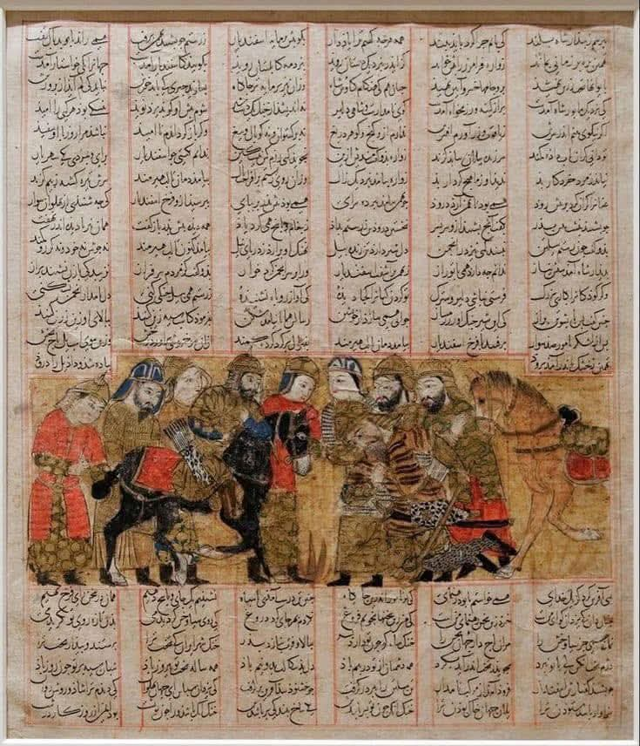
---

Keywords: Nariman, Nairi.manah, Kərəsāspa, Zāl, Rostam, Zabulistan, Zranka, Drangiana, Sakastān, Helmand River, Sharistan, Daykundi Province, Avestan geography, Arəzahī, Āzrah, Hazaragi, Neolithic Iranian haplogroups, J2a1, G2, Airyanem Vaejah, Iranian epic, Shāhnāmeh, pre‑Scythian, chronology.

---

